FUZZY

1. Basic notions

1.1 Fuzzy sets in uncertainty representation
Fuzzy sets are a generalisation of classical (crisp) sets that allow for partial membership. In classical set theory, an element either belongs or does not belong to a set. In contrast, instead of using the boolean (crisp) logic which has value in the set {0,1} when we talk about fuzzy systems we deal with the whole interval [0,1].

Uncertainty types:
- Missing values: the feature/property is unknown to us (I don’t know the car colour)
- Imprecise values: (the car is between 5 and 10 years old)
- Missing properties: I don’t have the whole property (not having the colour feature in the dataset)

Randomness: impossibility to establish the truth (predicting the weather)
Vagueness: information not representative (the car is fast [what does it means fast?])
Not reliable info: two contradicting information, at least one is wrong
Not complete trust in data

To represent and to study uncertainty we can use probability (belief function) or fuzzy sets (like to represent we can use a threshold, after 180km/h we can call it a fast car)

1.2 Membership functions (Membership Degree)
Membership functions determine the degree to which an element belongs to a fuzzy set. They map elements from the universe of discourse to the membership degree in the range [0, 1]. Membership functions can take various forms, such as triangular and trapezoidal and gaussian.

1.3 Core, support, alpha-cut, cardinality
- Core: the core of a fuzzy set represents the region where the membership function takes its maximum value (i.e., membership degree is 1). $\{x € X | f(x) = 1\}$
- Support: the support of a fuzzy set represents the region where the membership function is greater than zero. $\{x € X | f(x) > 0\}$
- Alpha-cut: an alpha-cut of a fuzzy set is the crisp set obtained by selecting all elements from the universe of discourse (domain) whose membership degree exceeds a certain threshold $\{x € X | f(x) ≥ α\}$. (Note: if α = 1 it is the core)
- Strong alpha-cut: $\{x € X | f(x) >α\}$
- Cardinality: the cardinality is the sum of the membership degrees of all the elements of the fuzzy set, it can be computed only for discrete and not for continuous one.
- Norm of the support: is the "size" of the fuzzy set or the number of elements that have a non-zero membership degree. It is written as ||supp(f(x))||

1.4 Measure of fuzziness
Entropy is a measure of the fuzziness or uncertainty associated with a fuzzy set. It quantifies the average amount of information required to describe or predict the membership values of the elements in the set. Higher entropy values indicate higher fuzziness (aka less crisp set) or uncertainty.

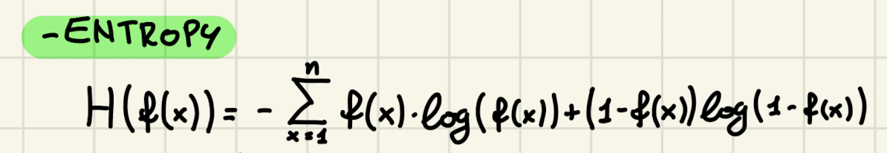

We can also compute the so-called fuzziness of the set which can be found with the Hamming distance or with the Euclidean distance.

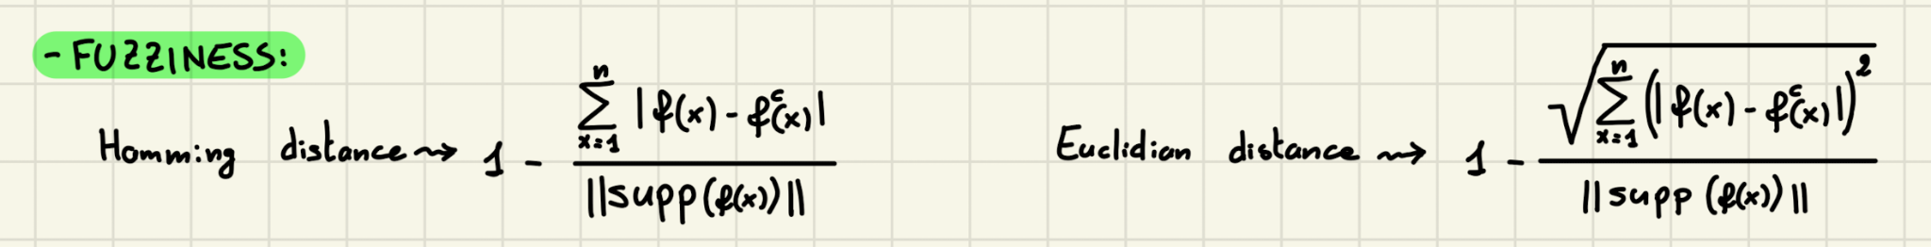

1.5 Set operators: min, max, not, t-norms, OWA
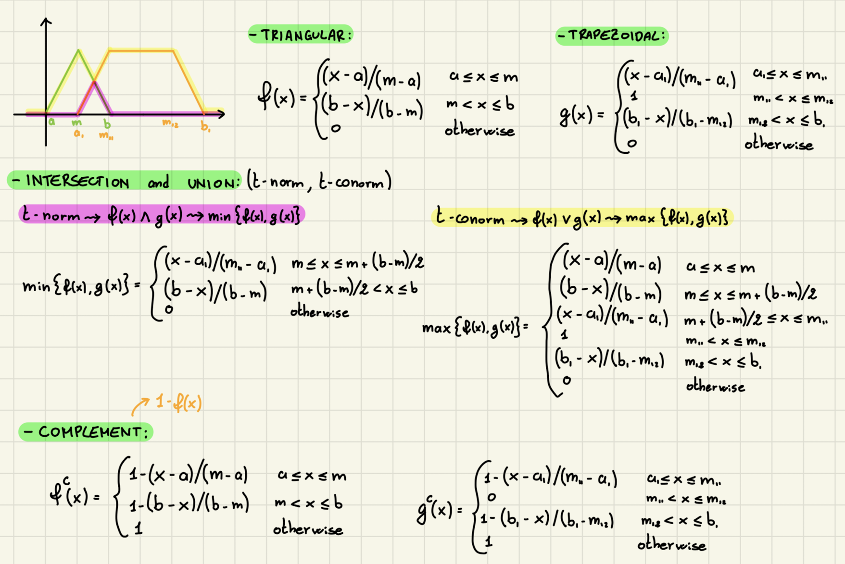

2. Fuzzy inference
Fuzzy logic uses fuzzy rules to model relationships between inputs and outputs.
These rules are expressed using linguistic terms and if-then statements.
E.g. "If temperature is high, then air conditioning should be strong."

The process of applying fuzzy rules to determine the output or make decwisions based on fuzzy inputs is called fuzzy inference, that typically involves steps such as:
- Fuzzification: converting crisp inputs into fuzzy sets (an example it to convert temperature = 27 to one or more membership degrees)
- Rule evaluation/inference engine: determining the degree of satisfaction of each rule. As an example of rule we can use IF (x₁ is small) and (x₂ is short) THEN y is bad
- Aggregation: combining rule outputs.
- Defuzzification: converting fuzzy outputs into crisp values

We saw 2 fuzzification methods:
- The horizontal approach consists in asking to a population if an element belongs to a particular set (the output is either yes or no).
- The vertical approach consists in asking if an element is or not inside an alpha cut to determine how much is membership degree.

Various defuzzification methods exist, including the center of gravity method, the maximum membership method, and the height method. The choice of defuzzification method depends on the specific application and the desired interpretation of the fuzzy output.

The output we obtain from the rule evaluation are then aggregated and transformed in crisp value. We have two possible strategies:
- FATI (First Aggregate, then infer): we first aggregate the output given from the rule elaboration obtaining a new fuzzy set (usually we use the max of the fuzzy sets given by the rules). After the aggregation we can use center of gravity or mean of maxima to find a unique crisp value.
  - With the center of gravity you consider how the mass is distributed 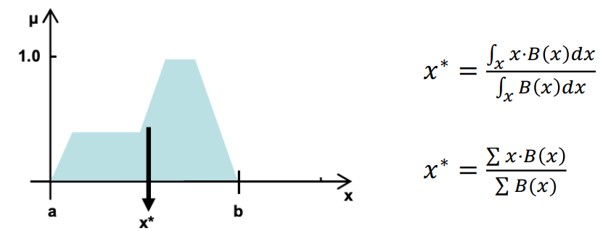
  - With the mean of maxima we compute the infimum and supremum 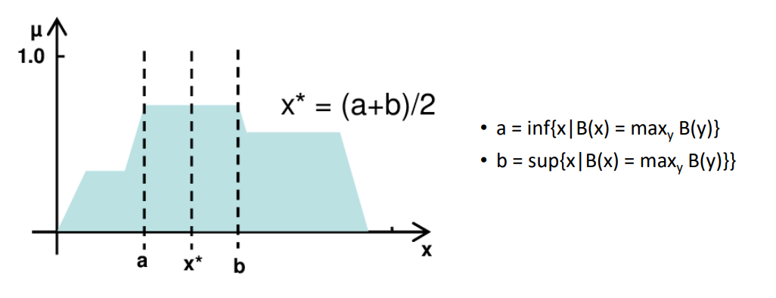
- FITA (First Infer, then Aggregate): we first apply a defuzzification technique to every fuzzy set gave as output from the rule processing (by using mean of maxima or center of gravity), then we aggregate them.
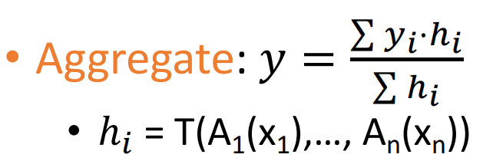

2. Operators in fuzzy propositions
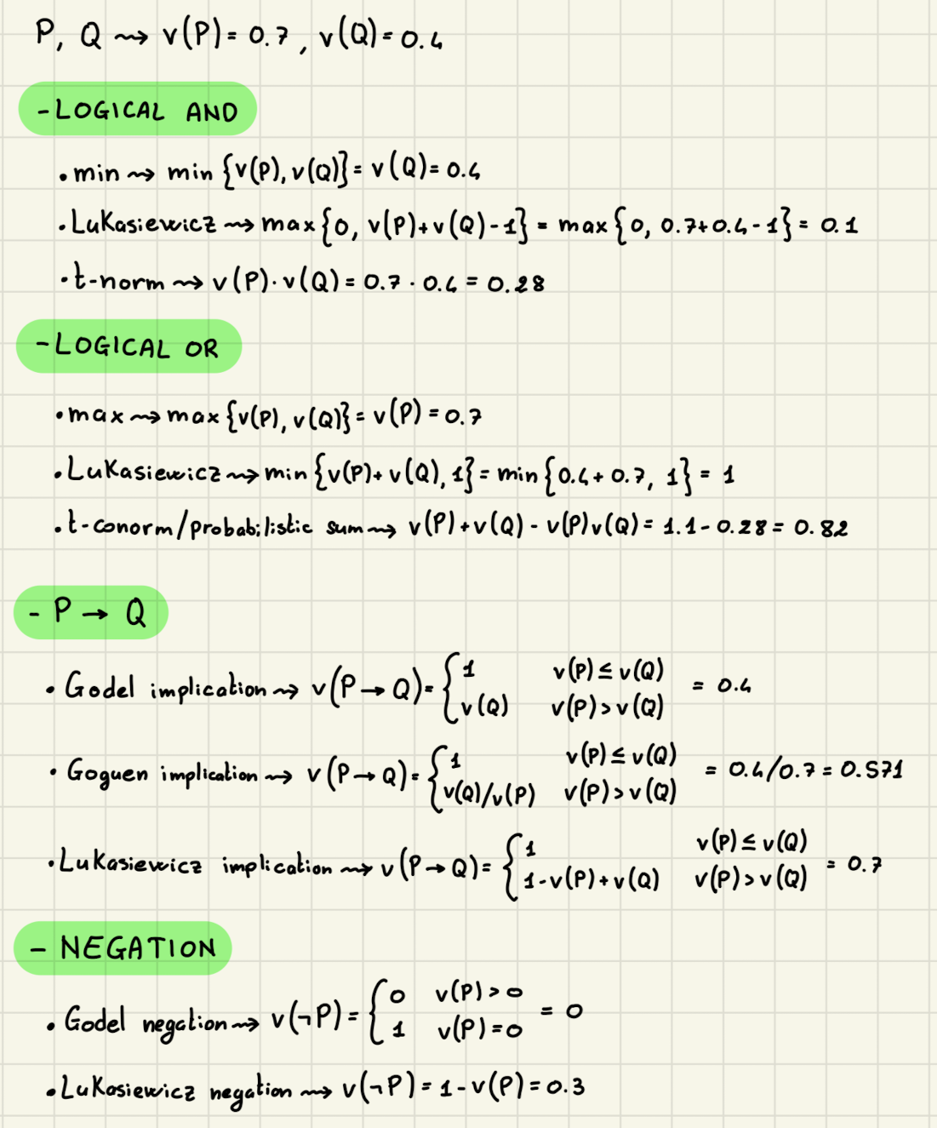

3. Linguistic variables
A linguistic variable represents a quantity or attribute that is described using linguistic terms rather than precise numerical values.

A linguistic variable is a tuple (L, T(L), U, G, M) with:
- L the variable name, ex. temperature (what you are discussing about)
- T(L) the linguistic terms, are the labels associated with the linguistic variables, they can be primitive (cold, warm) or generated (very cold, very warm). ex. the set of values that L can get: {cold, warm, hot}
- U is the universe of discourse, ex. [0,40] celsius degrees (the domain of L)
- G set of linguistic rules, is the grammar that generates the names of L, ex. “very very cold”, “not very hot”
- M set of semantic rules to give a meaning to each term x ∈ T(L).
For each term x, M(x) is a fuzzy set (membership function) that maps U to a membership degree: M(x) : U → [0, 1]. In basic words: M creates the fuzzy set for each linguistic term (like cold, warm and hot).

For example, consider a temperature control system with an input variable "temperature" and linguistic terms such as "cold," "warm," and "hot." Fuzzification would involve determining the degree to which the current temperature value belongs to each of these fuzzy sets, assigning membership degrees like "0.2" for "cold", "0.7" for "warm", and "0.3" for "hot" based on the temperature value and the corresponding membership functions.

Linguistic modifiers:
- Concentration → VERY(A) = A²
- Dilation → ENOUGH(A) = √A
- Contrast → SURELY(A) = 2(A²) for A ≤ 0.5; A-1 for A ≥ 0.5

4. How to define membership functions
- Determine the range or domain of the variable for which you want to define the membership function. For example, if you are working with the variable "temperature" and its range is from 0 to 100 degrees Celsius, the universe of discourse would be [0, 100].
- Determine the number of Fuzzy Sets that will represent different degrees of membership for the variable. For instance, you might define fuzzy sets like "Cold", "Warm" and "Hot" for the temperature variable.
- Choose the Shape of the Membership Functions (triangular, trapezoidal, etc.)
- Define the parameters of the Membership Functions: for example, for a triangular membership function, you would need to specify the coordinates of the three points that define the triangle.
- Assign Membership Values: assign membership values to elements within the domain based on their degree of membership to each fuzzy set (typically between 0-1).

5. Hints to possibility theory
Possibility theory is a mathematical framework that deals with uncertainty and vagueness in a similar way to probability theory but with different underlying principles.

5.1 Possibility distribution
A possibility distribution represents the degree of possibility of events or propositions. It assigns a possibility value to each event. Unlike probability distributions, which assign probabilities that sum to 1, possibility distributions do not have such a constraint. A possibility distribution can be represented by a set of possibility measures or a possibility mass function.

5.2 Necessity, possibility measures (capacity)
Are used to quantify the degree of necessity and possibility for a given event or proposition.

Necessity: indicates the minimum degree to which an event must occur
Possibility: represents the maximum degree to which an event can occur

These measures are typically expressed as values between 0 and 1, where 0 denotes impossibility and 1 denotes certainty. The sum of necessity and possibility measures for a given event is not necessarily 1.

5.3 Possibility vs probability
Possibility theory and probability theory differ in their interpretations and mathematical foundations.

Probability theory
- deals with uncertainty in situations where the underlying events are governed by known or assumed probability distributions
- it assigns numerical probabilities to events based on their likelihood of occurrence
- assumes complete knowledge of the underlying events

Possibility theory
- it’s suitable for situations where the events or propositions have incomplete or vague information
- allows for more flexible and subjective assessments of uncertainty
- deals with the concept of ignorance or lack of knowledge ⟹ events with possibility measure 0 are considered impossible, events with possibility measure 1 are considered certain, and events with possibility measures between 0 and 1 are regarded as more or less possible.

6. Fuzzy Control
Fuzzy control is a methodology that uses fuzzy logic to design and implement control systems capable of handling uncertainty and imprecision. Fuzzy control is particularly useful when dealing with systems that are difficult to model or have nonlinear or complex behaviour.

Keyconcepts of fuzzy control:
- it uses fuzzy sets to represent linguistic variables
- consists of a rule base, which contains a set of fuzzy rules (if-then statements) that encode expert knowledge or heuristics about the control problem
- can incorporate adaptive or learning mechanisms to improve their performance.
  - adaptive fuzzy control involves adjusting the parameters of the membership functions or the fuzzy rule base based on online feedback from the controlled system.
  - learning fuzzy control methods (reinforcement learning) can be used to optimise the fuzzy control system's behaviour through iterative learning and adaptation.

7. Fuzzy Clustering (and its evaluation)
It’s a technique used to group data points into clusters based on their similarities, allowing for partial memberships where points can belong to multiple clusters of various degrees.

Fuzzy C-means (FCM) is an iterative clustering algorithm that assigns data points to clusters based on their similarity. It extends k-means introducing fuzziness, assigning iteratively points to clusters, based on their distances from cluster centers and updating the membership values and cluster centers until convergence. It is particularly useful when dealing with data that exhibit uncertainty and overlap.

To evaluate fuzzy clustering we rely on the fuzzy partition coefficient (FPC): measures the fuzziness or compactness of the obtained clusters.
It quantifies how well data points are partitioned among the clusters (range 0-1).

EVOLUTIONARY COMPUTING

Black Box Model:
Three different types of problems
- Input → if is is unknown it is optimization
- Model → if is is unknown it is modelling
- Output → if is is unknown it is simulation

1. Optimization problem (unknown input):
Example: salesman problem, time tables of university, 8 queens problem.

8 queens problem with one possible solution: given an 8 x 8 chess board, place 8 queens on the board without any conflicts (two queens conflict when they share the same row, column or diagonal).
This is an example of an optimization problem since we have the model and the desired output but we have to find the inputs (aka the combination of queens) with a constraint satisfaction.

The fitness will be evaluated based on the concept of penalty:
- penalty of one queen: n of queens she can check
- penalty of a configuration: sum of penalties of all queens

Penalty must be minimised → fitness of a configuration is the inverse penalty, to be maximised.

Steps for solving the problem
- Representation:
- Phenotype: a board configuration
- Genotype: a permutation of the number 1-8
- Recombination: cut and crossfill crossover (fill missing values to have always permutation of 8 values)
- Mutation: small variation in one permutation e.g. swapping values of two randomly chosen positions
- Parent selection: best 2 of random 5 (where best two are evaluated according to n of queens they check
- Survival selection: replace worst
- Pop siz
- N of offspring
- Initialization: random
- Termination condition: solution
This is only a set of parameters and operators that we can use

2. Modelling problems (unknown model):
It is what we do in supervised machine learning.
Example: check if someone will give back the money borrowed.

3. Simulation problems (unknown output):
We have a given model and wish to know the outputs that arise under different input conditions.

Optimization vs constraint satisfaction
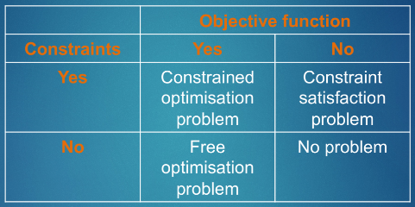

P: problems that can be solved in a reasonably fast program. Solvable in polynomial amounts of time and are also verifiable in polynomial time. Example: multiplication or transform of a word in lowercase.
NP: Solvable in exponential amount of time and verifiable in polynomial time. Example: sudoku (hard to do, but easy to check if it is correct)
NP-complete: Solvable in exponential amounts of time and verifiable in polynomial time and any other problem in NP can be reduced to NP-complete by a polynomial algorithm. If you find an algorithm to solve a NP-complete problem in a polynomial time then you can use the same algorithm to solve all the other NP-complete problems in polynomial time.
- They belong to the NP class: This means that if someone gives you a potential solution to an NP-Complete problem, you can quickly check if it's correct or not.
- They have a special property: Any problem in the NP class can be transformed or reduced into an NP-Complete problem. This transformation is done by a special trick, like a magic algorithm, that takes a reasonable amount of time to run. It's like turning one puzzle into another.

NP-hard: complex as NP-complete (all the problems in NP-complete can be reduced to NP-hard) but can not be verified in a polynomial time.

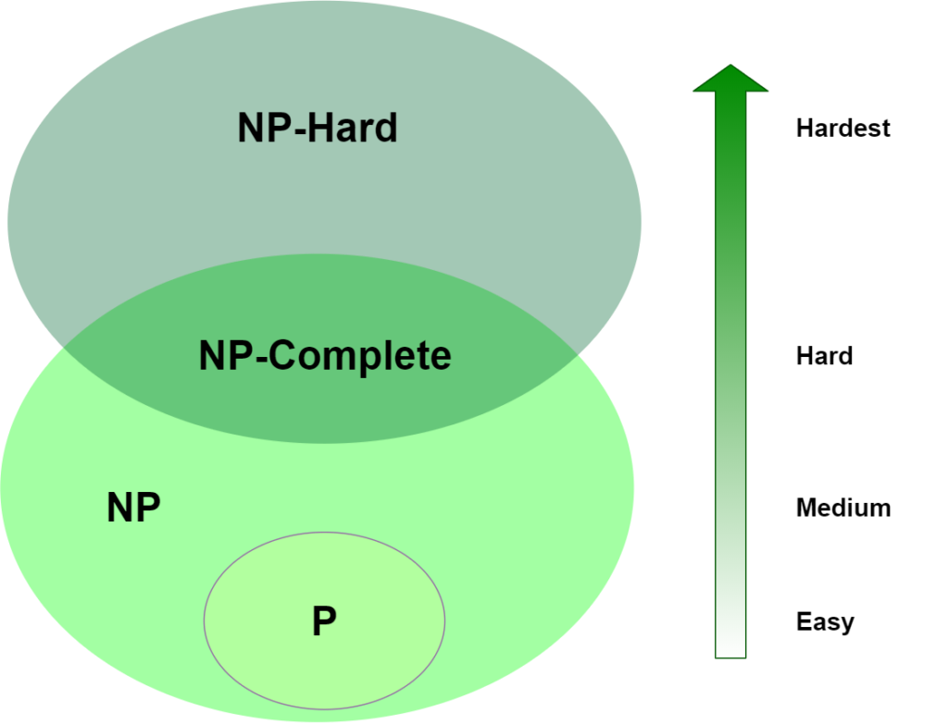

8. Minimal background on optimization, Biological inspiration
Evolutionary computing is a branch of optimization algorithms that draws inspiration from biological evolution and natural selection to solve complex optimization problems. It encompasses several metaheuristic algorithms, including genetic algorithms, evolutionary strategies, and genetic programming. These algorithms mimic the process of biological evolution to search for optimal or near-optimal solutions.

1. Darwinism
In the view of evolution, Darwinism emphasises the role of natural selection: it’s based on the principle that individuals who are better suited to their environment have a higher chance of reproducing and go on in the future (survival of the fittest).
All the environments have a finite number of resources ⟹ only a limited part of individuals can survive, so selection is inevitable.

Also, all live forms have some kind of reproduction that drives the selection process.

2. Genetics
Genetics plays a crucial role in understanding the mechanism behind evolution.

- Phenotypic traits: observable characteristics (colour of eyes, height, physician differences that adapt to the environment, like the harm of a tennis player). If the phenotypic traits lead to higher change of reproduction they will be inherited by the sequent generations.

- Genotypic traits: genetic composition of an organism. Typically expressed using binary numbers. Small changes or mutations in the genotype can lead to a corresponding variations in the organism’s phenotype

e.g.
Genotype: 011101
Phenotype: the representation of the genotype as integer using binary numbers

As said above, EC draws inspiration from biological evolution and natural selection, it can be seen focusing on its key concepts:
- Genetic representation: solutions to optimization problems are represented as strings of genes (genotypes)
- Population
- Fitness function & selection
- Reproduction & variation
- Replacement
- Evolutionary process iterates over generations
(see below)

Recap of EC metaphor
- A population of individuals exists in an environment with limited resources
- Competition for those resources causes selection of those fitter individuals that are better adapted to the environment
- These individuals acts as seeds for the generation of new individuals through recombination and mutation
- The new individuals have their fitness evaluated and compete (possibly also with parents) for survival
- Over time natural selection causes a rise in the fitness of the population
- EAs fall into the category of “generate and test” algorithms: we will not reach the optimum but we will do our best
- They are stochastic (aka have a probabilistic element inside), population-based algorithms
- Variation operators (like recombination and mutation) create the necessary diversity and facilitate novelty
- Selection reduces diversity and acts as a force pushing quality

To improve the quality of species we have two strategies that can be applied at the same time
- Push toward novelty: by increasing the population diversity with mutation and recombination
- Push toward quality: by decreasing population diversity by selection of parents and survivors

9. Components of Evolutionary Algorithms
- Initialization: algorithm starts by creating an initial population (randomly). It is the basic unit of evolution because the population is evolving, not the individual.
- Fitness evaluation: evaluates the quality of each candidate solution in the population.
- Selection operators: they take the whole population into account.
The scope of selection is to push the population towards higher fitness. It identifies individuals that can become parents for the next generation and that will survive.
- Reproduction and variation: through reproduction, selected individuals and generate offspring by combining genetic material → introduction of variation and diversity. This is typically done through variation operators (recombination and mutation). They generate new candidates' solutions.
  - Mutation (arity 1 ⟹ one individual required). Causes small random variance and acts on one genotype (aka the bit). It introduces small random changes in the genetic material (chromosomes) of individuals in a population. It plays a crucial role in maintaining genetic diversity, preventing premature convergence, and exploring new regions of the search space. Mutation is exploitative (it creates random small diversions staying in the area of the parent ⟹ only mutation can introduce new info= alleles)
  - Recombination (arity > 1). If arity = 2 it is a crossover. It merges information from parents into offspring. Crossover is explorative (make a big jump to an area somewhere in between two parent areas ⟹ only crossover can combine info from two parents; however doesn’t change the allele frequencies of the population since doesn’t introduce new info)

- Replacement: the new offspring replace less fit individuals in the population → only the fittest individuals survive
- Termination condition: when we should stop?
- When we reach some known/hoped fitness
- When we reach some specified number of generations without fitness improvement
- When we reach some maximum allowed number of generations
- When we reach some minimum level of diversity (aka stop when the population is more or less equal)

11.1 Selection
From a set of μ parents and λ offspring ⟹ to a set of μ individuals forming the next generation
- Age-Based Selection/Generation Replacement: fitness isn’t taken into account, we just delete the oldest
- Fitness-Based Replacement & (μ+λ)-selection: choose best μ as parent for the new generation, while λ offspring are discarded ⟹ pick higher fitness
- Elitism: It is similar to age-based selection and fitness based selection: we remove all the parents (like age based selection) but if the fittest individual of the entire population is a parent, we do not remove it and we keep it in the new generation. To overcome this we randomly remove one of the offspring.
- Roulette wheel selection: assigns probabilities to individuals based on their fitness
- Tournament selection: random selection of a subset (K) of individuals and comparison of their fitness values. We then keep only the single fittest individuals among the K. We repeat the tournament until all the elements have competed in a tournament. Also, when one competes it can not compete again in another tournament.

11.2 Population Management
Population management involves controlling the size and diversity of the population throughout the evolutionary process. It ensures that the population remains diverse and dynamic, facilitating exploration and avoiding premature convergence.

Two different population management models exist:
- Generational model:
  - Each individual survives for exactly one generation
  - The entire set of parents is replaced by the offspring (age base selection)
- Steady-state model
  - One offspring is generated per generation
  - One member of population replaced

Generation Gap
- The proportion of the population replaced
- Parameter = 1.0 for GGA, = 1/pop_size for SSGA

12.Variants
Genetic Algorithms (GAs), Evolutionary Programming (EP), and Particle Swarm Optimization (PSO) are popular variants of evolutionary computation. While they share the common principle of using evolutionary-inspired techniques to solve optimization problems, each variant has its own distinct characteristics.

12.1 Genetic algorithms
GAs operate based on the principles of natural selection and genetics. They typically use a binary string representation of candidate solutions (chromosomes) and apply genetic operators such as crossover and mutation to create new offspring solutions. GAs emphasise the exploration of the solution space and the exploitation of promising solutions. The population evolves over generations, and individuals with higher fitness have a higher probability of being selected for reproduction. GAs have been successfully applied to various optimization problems, including those with discrete or continuous variables.

12.2 Evolutionary programming
Focuses on directly evolving the behavior of individuals to solve optimization problems. It emphasizes the optimization of individual components rather than entire solutions. EP employs mutation as the primary operator. Unlike GAs, EP does not typically use crossover. EP is well-suited for problems where the structure of the solution is not well-defined or where the problem involves continuous variables. EP has been applied to a wide range of domains, including control systems, neural network training, and robotics.

12.3 Particle swarm optimization
It’s a population-based optimization algorithm inspired by the social behavior of bird flocking or fish schooling. In PSO, candidate solutions are represented as particles moving in a multidimensional search space. Each particle adjusts its movement based on its own best-known position and the best-known position among all particles in the population. PSO focuses on exploration and exploitation through the coordination and interaction of particles. The algorithm seeks to find optimal solutions by iteratively updating the positions and velocities of particles. PSO has been applied to various optimization problems, including continuous, discrete, and combinatorial optimization.

15. Fuzzy Systems and Evolutionary computing hybridization
The hybridization of fuzzy systems and evolutionary computing leverages the strengths of both approaches to address complex problems. Here are some key aspects of the hybridization:

1. Fuzzy Rule-Based Genetic Algorithms (FRB-GA): fuzzy rules and fuzzy inference mechanisms + genetic algorithms.
The fuzzy rules define the behavior of the system, and the genetic algorithm optimizes the rule parameters or structure.

2. Fuzzy Adaptive Particle Swarm Optimization (FAPSO): fuzzy logic + Particle Swarm Optimization.
Fuzzy logic is used to dynamically adapt the particle swarm's behavior by adjusting the inertia weight, acceleration coefficients, or other parameters. The fuzzy rules guide the swarm's movement, enhancing its exploration and exploitation abilities.

3. Fuzzy Evolutionary Programming (FEP): fuzzy logic + Evolutionary Programming.
Fuzzy rules are employed to adjust the mutation operator, or other parameters during the evolutionary process. The fuzzy logic-based adaptation allows the evolutionary algorithm to dynamically fine-tune its exploration and exploitation balance.

4. Fuzzy Genetic Programming (FGP): fuzzy logic + Genetic Programming.
Fuzzy logic is employed to handle uncertainty, fitness evaluation, or incorporate domain-specific knowledge into the genetic programming process. FGP enables the evolutionary search to evolve fuzzy-like structures, enhancing the system's ability to handle vagueness or imprecision.

